|  |
| --- |
| Project Report   HealthPlus  TEAM-NK-WDD-03 |

Contents

1. Definition of the Problem 2

2. Requirement Analysis 3

3. Design Phase 5

4. Architecture of Website 7

5. Project Tracking/Monitoring Activities 8

6. Source Code 10

7. User Guide 14

# 1. Definition of the Problem

After reading the project specifications, the developer states the scope of the project very briefly. This is referred to as the problem definition. For example, in the case of HealthPlus portal, queries of various staff members can be one or all of the following: i. How many company names can be displayed on the marketplace page at a time? Project Guide V 1.0 Aptech Ltd ii. What information should be displayed about each company in the marketplace? iii. Will the rates per day for ads be displayed for each company in the marketplace? iv. Will the users be able to contact the company whose ad is displayed on the portal? v. Will other companies be able to contact HealthPlus after visiting the site to display their ad on the HealthPlus portal? After consulting several IT companies and considering the budget constraints, the management of HealthPlus has decided to launch the Web application as a Single Page Responsive Web application. Hence, the project will use HTML5, CSS3, JavaScript, Geolocation API, Web Storage, AngularJS, and Bootstrap 3.3 libraries from getbootstrap.com, jQuery plugins, and, Notepad++, or other HTML editors. Also, the site will be tested on popular browsers and mobile emulator software.

# 2. Requirement Analysis

This phase consists of following:

* **List of inputs to the system** 
  + **User will give Appointment Booking information**
  + **User will be able to create his medicine dosage schedule**

* **List of outputs expected from the system** 
  + User will get his appointment details
  + User will get the dosage details
* **Hardware Requirement**
  + Intel Core i3 Processor or higher
  + 1 GB RAM or higher
  + Color SVGA
  + 80 GB Hard Disk space
  + CD-ROM or DVD-ROM drive
* **Software Requirement**
  + Windows 8, 10, or higher
  + HTML5 and JavaScript supporting browser
  + Bootstrap 3.3 libraries from getbootstrap.com, jQuery plugins, and
  + CoffeeCup, Notepad++, or other HTML editor

## Project Plan 1. Project Details

* **Name of the Client:** Sir Fahad.
* **Date of the Project Plan:**

**8/10/2022**

* **Project Vision/Objectives:**

They asked for a static medical care website that included the pages and details above as well a well responsive and well-made contact us and feedback forms with validation.

* **Scope:**

We have created a Static Website .Our project is based on a Hospital website

“Healthplus”.In it we have covered all the necessary things that a healthcare website contains. People can see there appointment slots on it, can get knowledge about experienced doctors so that they can get consult from them .There are different pages like homepage, contact us, feedback, about, and consultancy that can be visited by anyone it’s a healthcare portal and can help people in many ways.

## ● Project Organization with Responsibilities and Authorities

**Qirat:** Designed Contact Us, Appointment page and collected all the important images and designs.

**Aaiza:** Designed Feedback form and did all documentation work also helped in picking the color themes.

**Uzair (Group leader):** Made Footer and did efforts too. made things attractive.

**Danish:** Made Home Page, Blog Page and Consultancy page sliders and all and worked on linking of pages. Also Made the website responsive.

# 3. Design Phase

Design phase involves the preparation of the blueprint of the proposed system.

## ➢ Designing the GUI Standards

For the HealthPlus portal, multiple screens have been created and linked to each other. Each of these screens should have a consistent look with respect to appearance, and theme used. The font styles, color of the labels, design and appearance of the command buttons, the appearance of header and footer, and the design and size of controls, such as check boxes or text boxes should be consistent through all the forms.

In the case of HealthPlus portal, the modules could be for:

● Appointment

● Medical Dosage

● Dental Service

## Document Design

|  |  |
| --- | --- |
| **Property** | **Value** |
| Document Theme and Color Scheme | #8e1a4b, #ef233c, #fff, #111 |
| Form-Background Color | #fff |
| Title-Font Size | 1.7em |
| Title-Font Color | #8e1a4b |
| Title-Font Style | Signika Negative, lobster2 |
| Title-Alignment | left |
| Background color of Controls on the form | #fff |
| Foreground color of Controls on the form | #8e1a4b |
| Control Caption-  Font Size | 1.25em  1.7em |
| Control Caption- Font Color | gray  #8e1a4b |
| Control Caption- Font Style | Signika Negative, lobster2 |
| Control caption and controls-Alignment | center |
| Command button-Alignment | right |

## ➢ Assigning and Monitoring Tasks

|  |  |  |  |  |
| --- | --- | --- | --- | --- |
| **Date:** | **Project Plan/ Milestone** | **Status of the Activity** | **Remarks** | **Responsibility** |
| **10-Aug-2022** | **Homepage**  Designing | **Complete** | **-** | **Aaiza**  Qirat |
| **11-Aug-2022** | **Contact Us**  Feedback  Appointment | **Complete** | **-** | **Uzair**  Danish |
| **12-Aug-2022** | **Final touches**  Designing  Linking Pages | **Complete** | **-** | **Aaiza**  Qirat  Uzair  Danish |

# 4. Architecture of Website

**Site Map:-**

**HealthPlus**

**Appointments**

**Feedback**

**About**

**Contact us**

**Home**

**Vitals**

**Personal**

**Dosage**

**Schedule**

**Medical**

**Health**

# 5. Project Tracking/Monitoring Activities

|  |  |  |
| --- | --- | --- |
| **S. No** | **Aspect Tested** | **Suggestion/Remarks** |
| 1. | Have all the modules been properly integrated and are they completely functional? | YES, COMPLETED |
| 2. | Does each unit meet its objective and purpose?  Are all the validations happening properly? | WORKING PROPERLY |
| 4. | Is the GUI design consistent all over? | YES |
| 5. | Are the codes working as per specification? | YES |
| 6. | Does the application’s functionality resolve the client problem, and satisfy his/her needs completely? | YES |
| 7. | Have the hardware and software been correctly chosen? | PROPERLY INDEED |
| 8. | Additional features and utilities that give value addition to the entire project. | YES |

## 1. List of forms to be created

|  |  |  |
| --- | --- | --- |
| **Page/Form Name** | **Description** | **Controls on the Page/Form** |
| **Homepage** | It’s a Title page. | It displays the purpose of the website. |
| **Feedback** | This page allows user to provide their feedback and questions. | It displays the questions asked by the user. |
| **Book an Appointment** | Allows user to book an appointment for a visit. | It displays the timings and slots available for appointments. |
| **Contact Us** | Allows user to contact our hospital for further information. | It displays contact displays such as email, phone numbers etc. |
| **Blog** | Allows user to learn more about our website and follow safety measures and health tips. | This page displays a list of health tips and safety measures for you. |
| **Our Team of Specialists** | Allows users to approach and learn about our professional team. | This page displays a list of highly qualified doctors all around the world. |

# 6. Source Code

**HEADER:-**

 <header>

        <div class="logo">

            <i class="fa-solid fa-kit-medical"></i> <h4>Health Plus</h4>

        </div>

        <nav class="myNav" id="myNav">

            <ul class="nav-list">

                <li class="nav-list-item"><a href="index.html" class="nav-link active">Home</a></li>

                <li class="nav-list-item"><a href="Appointments.html" target="_blank" class="nav-link">Appointments</a></li>

                <li class="nav-list-item"><a href="Medical Dosage.html" target="blank" class="nav-link">Medical Dosage Schedules</a></li>

                <li class="nav-list-item"><a href="Health Vitals.html" target="_blank" class="nav-link">Personal Health Vitals</a></li>

                <li class="nav-list-item"><a href="Blog.html" target="_blank" class="nav-link">Blog</a></li>

                <li class="nav-list-item"><a href="Contact.html" target="_blank" class="nav-link">Contact Us</a></li>

                <li class="nav-list-item" data-bs-toggle="modal" data-bs-target="#exampleModal" id="feedback"><a href="#" class="nav-link">Feedback</a></li>

            </ul>

        </nav>

        <div class="toggle-menu">

            <span></span>

            <span></span>

            <span></span>

        </div>

    </header>

**SLIDER:-**

    <section class="section hero-section">

*<!-- Swiper -->*

    <div class="swiper mySwiper">

        <div class="swiper-wrapper">

          <div class="swiper-slide slide-1">

            <div class="slide-content" data-aos="fade-up">

                <h3>Healthy Diet</h3>

                <p>

                    Eat a combination of different foods, including fruit, vegetables, legumes, nuts and whole grains. Adults should eat at least five portions (400g)

                    of fruit and vegetables per day. You can improve your intake of fruits and vegetables by always including veggies in your meal;</p>

                <p>Eating fresh fruit and vegetables as snacks; eating a variety of fruits and vegetables; and eating them in season.</p>

                <a href="Blog.html" target="_blank" class="myBtn">Read More</a>

            </div>

          </div>

          </div>

        </div>

        <div class="swiper-pagination"></div>

      </div>

    </section>

**FOOTER:-**

 <footer class="section section-footer">

        <div class="grid-4" data-aos="fade-up">

            <div class="popular">

                <h3 class="footer-headings">Popular Searches</h3>

                <ul class="footer-list">

                    <li class="footer-list-item"><a href="#" class="footer-links">Health Tips</a></li>

                    <li class="footer-list-item"><a href="#" class="footer-links">BMI Calculator</a></li>

                    <li class="footer-list-item"><a href="#" class="footer-links">Tips For Healthy Life</a></li>

                    <li class="footer-list-item"><a href="#" class="footer-links">Call Service</a></li>

                </ul>

            </div>

            <div class="About">

                <h3 class="footer-headings">About Us</h3>

                <ul class="footer-list">

                    <li class="footer-list-item"><a href="#" class="footer-links">Our Story</a></li>

                    <li class="footer-list-item"><a href="#" class="footer-links">Team Members</a></li>

                    <li class="footer-list-item"><a href="#" class="footer-links">Careers</a></li>

                    <li class="footer-list-item"><a href="#" class="footer-links">Privacy Policy</a></li>

                </ul>

            </div>

            <div class="quick-links">

                <h3 class="footer-headings">Quick Links</h3>

                <ul class="footer-list">

                    <li class="footer-list-item"><a href="Blog.html" class="footer-links">Blog</a></li>

                    <li class="footer-list-item"><a href="Health Vitals.html" target="_blank" class="footer-links">Personal Health Vitals</a></li>

                    <li class="footer-list-item"><a href="Medical Dosage.html" target="_blank" class="footer-links">Medical Dosage Schedules</a></li>

                    <li class="footer-list-item"><a href="Contact.html" class="footer-links">Contact Us</a></li>

                </ul>

            </div>

            <div class="support">

                <h3 class="footer-headings">Support</h3>

                <ul class="footer-list">

                    <li class="footer-list-item"><a href="#" class="footer-links">Donation Support</a></li>

                    <li class="footer-list-item"><a href="#" class="footer-links">Team Support</a></li>

                    <li class="footer-list-item"><a href="#" class="footer-links">Management</a></li>

                    <li class="footer-list-item"><a href="#" class="footer-links">Help Center</a></li>

                </ul>

            </div>

        </div>

        <div class="main-footer">

            <div class="logo">

                <i class="fa-solid fa-kit-medical"></i> <h4>Health Plus</h4>

            </div>

            <p>&copy; 2022 Health Plus. All Rights Reserved</p>

        </div>

    </footer>

# 7. User Guide

1. **System Requirements:**

• Windows 8, 10, or higher

• HTML5 and JavaScript supporting browser

• Bootstrap 3.3 libraries from getbootstrap.com, jQuery plugins, and coffee Cup, Notepad++, or other HTML editor

1. **Screenshots:-**

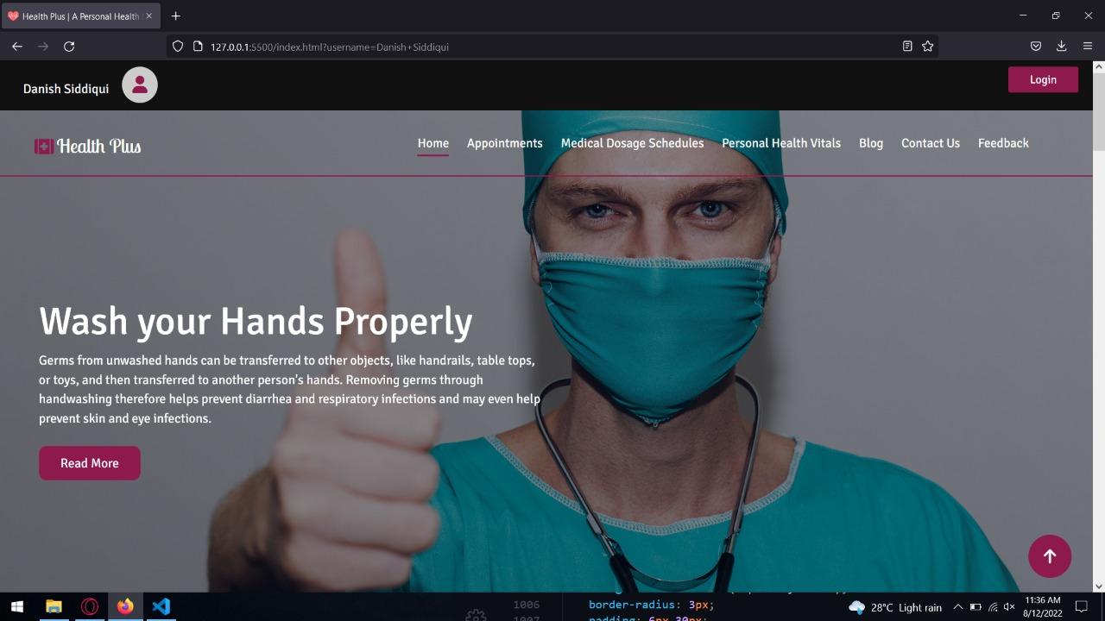

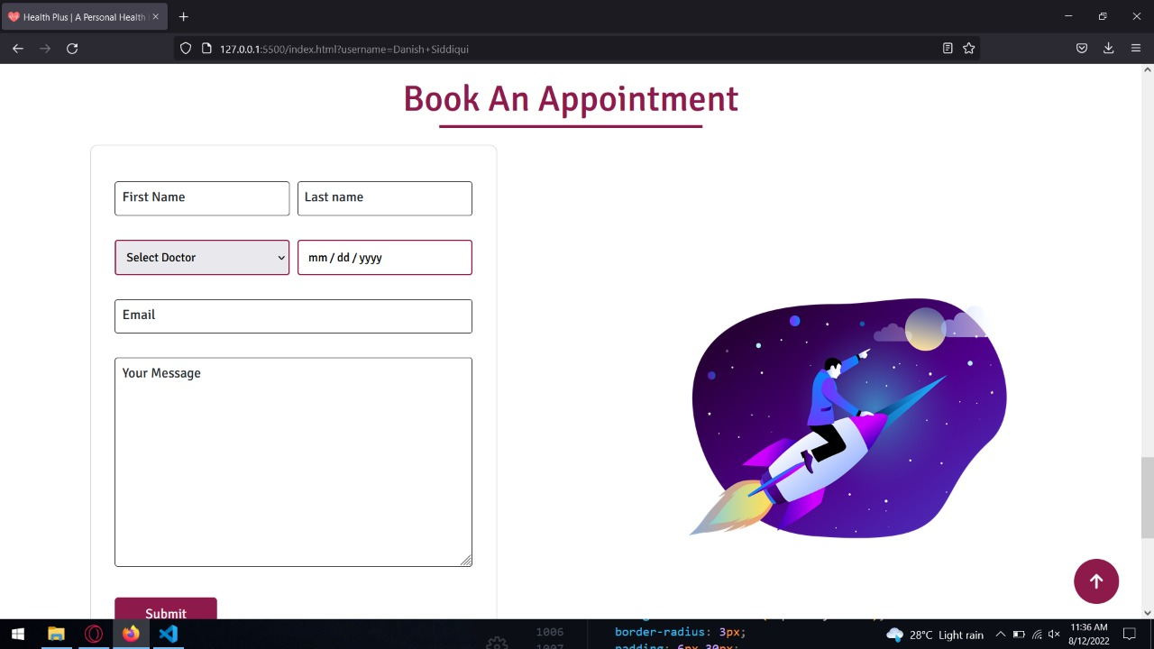

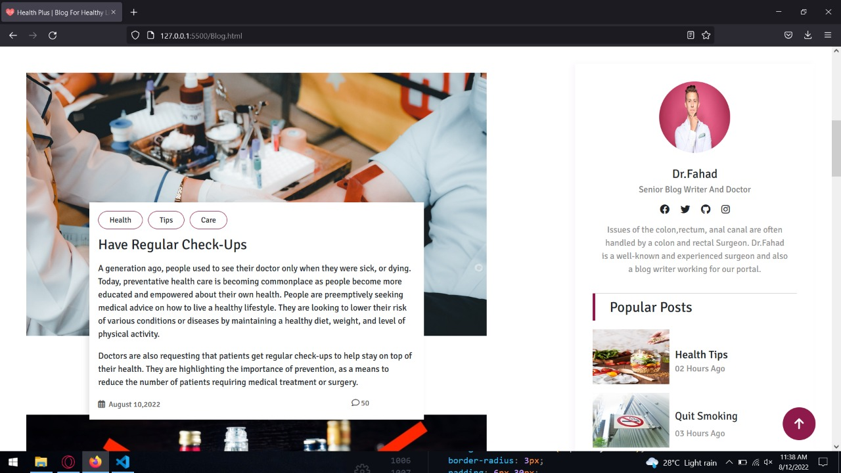

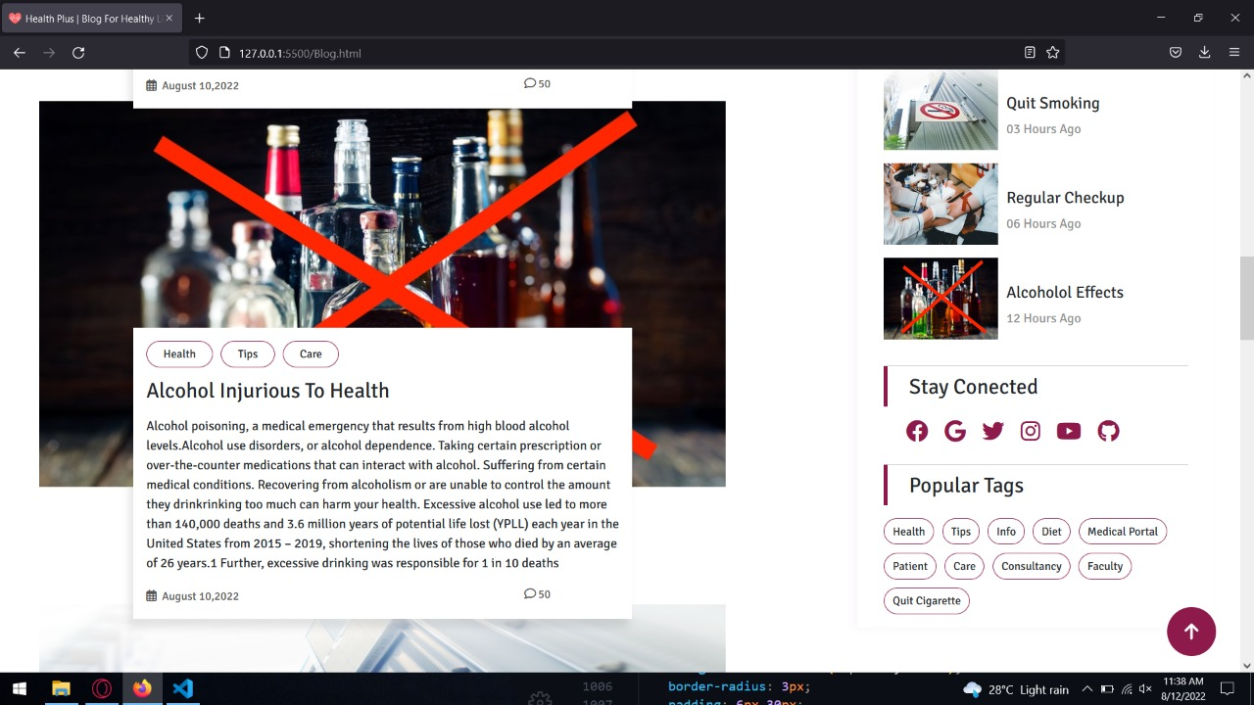

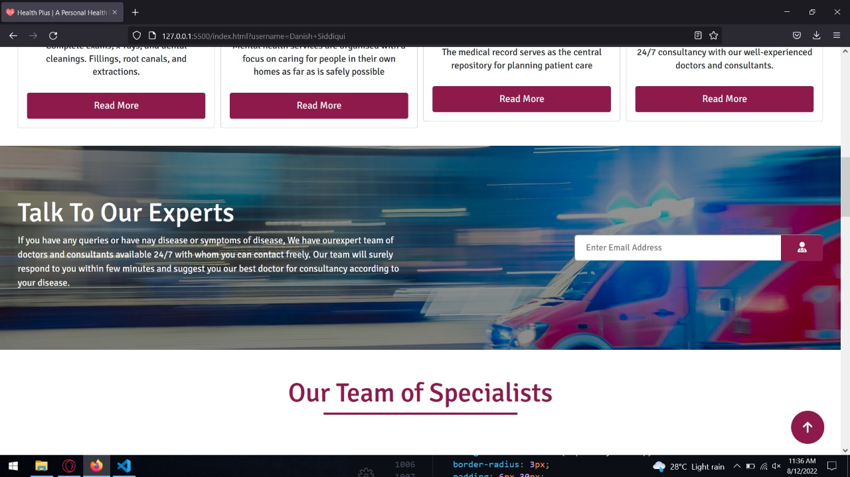

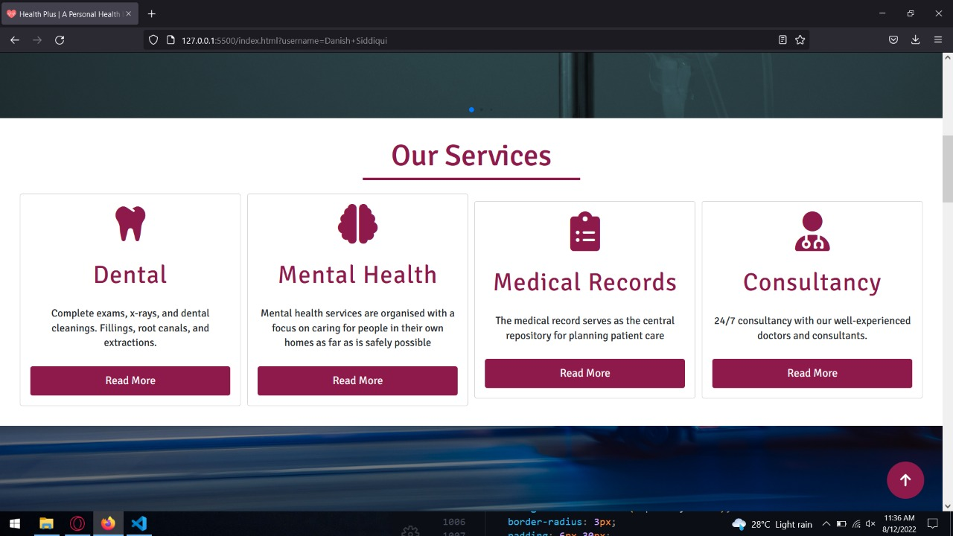

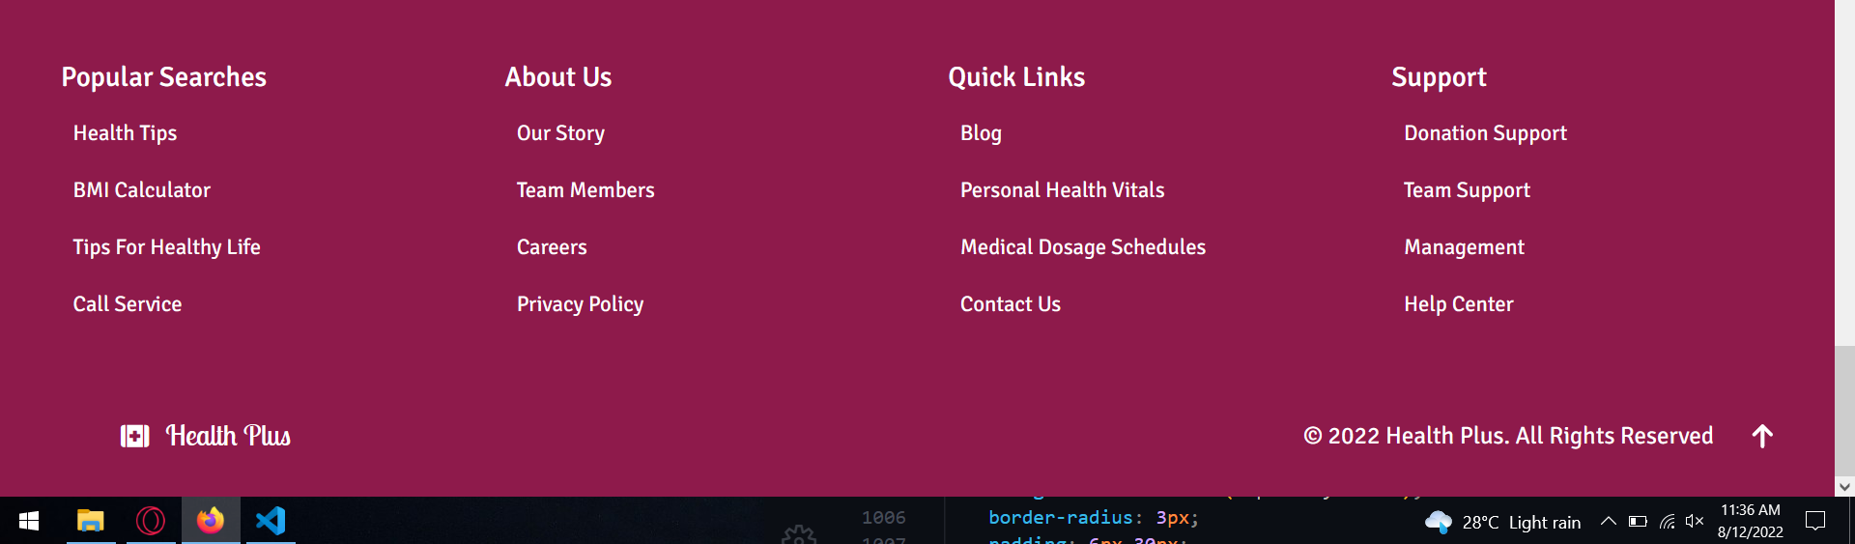

# Website Link :

**https://health-plus-dcc15.web.app**